**Title**

Proponents

Proponent1

Proponent2

**Notre Dame of Marbel University**

**MIT 251 – Software Engineering**

Brenda M. Balala, MIT

December 2023

**Table of Contents**

Contents

Introduction 3

Background of the Study 3

Statement of the Problem 3

Objectives of the Study 4

Concept of the Study 5

Methods 6

Hardware 6

Software 7

Data 7

Procedures 7

Design Methodology 7

Development Model 8

Requirements Analysis 8

Requirements Documentation 9

System Design 9

# Introduction

## Background of the Study

The social pension for itinerant senior citizens is a government initiative designed to address the needs of elderly individuals, particularly those in vulnerable sectors. This program focuses on providing financial support to senior citizens who have not had the opportunity to benefit from programs like the Social Security System (SSS) or the Government Service Insurance System (GSIS). It aims to ensure that even the most marginalized and economically disadvantaged seniors, especially those without formal pension coverage, receive the assistance they need to live with dignity and security in their later years.

Meanwhile, the process of disbursing social pensions remains entirely manual, with no technological systems in place to streamline or expedite the procedure. As a result, disbursement officers frequently encounter significant challenges, leading to delays and sometimes the failure to complete disbursements within the designated time frame. One major issue arises during the identity verification process, which often takes longer than expected, particularly when beneficiaries lack the necessary documentation. In some cases, disbursing officers also face difficulties in verifying the legitimacy of individuals attempting to claim benefits despite not being included on the official list. These challenges are inherent in the current manual system and are unlikely to improve without the integration of technology to automate and simplify the process.

In addition to the problems mentioned, grievances are also increasing due to various reasons, such as those who did not receive grants or received but not enough. There are also beneficiaries who receive double which is very worrying for the agency because it greatly affects, not only the overall accomplishment of the agency but also to the thrust of the public to the agency. The disbursing officers will also have difficulty in liquidating the payroll especially since the COA is focusing on program operation.

To solve these problems, the agency needs a centralized database system with strict policies (database contains and roles). through this, the process will be accelerated, the integrity of the data will be protected, and possible problems will be mitigated in the present. The proposed Comprehensive Payroll Management and Payment Reconciliation System will address key issues in the social pension program, such as data inconsistencies, delays, and challenges in tracking beneficiary statuses. By automating data validation, the system will ensure accurate beneficiary information, reduce errors and fraud, and streamline payroll processing and payment reconciliation for timely disbursements. Real-time monitoring and regular data updates will keep beneficiary information up to date, improving payroll accuracy. Scalable technologies like Redis, Celery, and Docker will handle growing data loads, while security measures like role-based access control and data encryption will protect sensitive information.

## Statement of the Problem

1. Lack of data quality assurance in the newly endorsed beneficiary from the LGU would result in data inconsistencies like duplicate and fraudulent entries that could result in larger problems like increase in grievances due to lower or higher entitlement.
2. Manual data processing is susceptible for delay in government’s deliverables due to limited timeline particularly in the disbursement and liquidation processing.
3. The agency experiencing the problem is tracking their beneficiary status that hinders in the preparation of the listing of beneficiaries for payroll preparation.

## Objectives of the Study

General Objective:

To develop an Integrated Payroll Management and Payment Reconciliation System that ensures data quality assurance, accuracy, and efficiency in the disbursement of social pensions for senior citizens. The system aims to eliminate data inconsistencies, prevent fraudulent and duplicate entries, automate payroll processing and reconciliation, and provide real-time tracking of beneficiary status to enhance transparency and efficiency in the Social Pension Program of DSWD Field Office XII.

Specific Objectives:

1. To Develop and implement a data validation and quality assurance mechanism.
2. To automate the payroll processing, disbursement, and liquidation process.
3. To Integrate real-time monitoring and realtime reporting features to facilitate payroll process.

## Concept of the Study

**Figure1** Conceptual Framework



Users

There are seven types of users in the system, each with specific roles and responsibilities. The Project Development Officer is responsible for encoding waitlisted pension beneficiaries into the database system and validating their identities. The Quality Assurance Focal ensures the integrity of the potential beneficiary data and verifies the payroll before processing. The Monitoring and Evaluation Officer oversees program performance, ensuring that the system effectively tracks beneficiaries and disbursements. The Program Coordinator supervises the entire program and provides recommendations to the Regional Director for approvals. The Financial Analyst is tasked with preparing financial reports and supporting payroll reconciliation. The Disbursement Staff is responsible for the actual disbursement of social pensions to beneficiaries, ensuring payments are made accurately and securely. Finally, the Regional Director holds the authority for final approvals on beneficiary lists, payroll processing, and major program-related decisions.

Data Process:

In this conceptual framework, the end-user initiates a request to the web application, which operates within a Dockerized environment. The request is first received by the web server, which directs it to Redis, serving as a message broker to manage asynchronous task queues. Celery workers process these queued tasks, enabling efficient execution of background operations such as data processing and report generation. For database interactions, a load balancer or proxy server (e.g., HAProxy or ProxySQL) optimizes query distribution across multiple database instances, ensuring reliability and scalability. System performance and application health are continuously monitored using Prometheus, which collects real-time metrics, and Grafana, which provides a visual representation of system status, enabling proactive monitoring and management.

Business Process

The Beneficiary Data Management (BDM) Process begins when waitlisted beneficiaries are validated and approved at the regional level. After validation, they undergo quality assurance checks such as deduplication and name-matching. Once these checks are completed, the Program Coordinator recommends the beneficiaries for final approval by the Regional Director.

In the Payroll Processing stage, the verified list of beneficiaries undergoes an additional quality check to prevent inconsistencies in disbursement. Once confirmed as accurate, the Finance team proceeds with payroll preparation.

During Payment Reconciliation, disbursements take place in designated field locations such as PUROK. Before payment, verification is conducted using visual checks, document validation, photo capturing and fingerprint. Only after successful verification do the disbursement staff release the payments to beneficiaries.

The Liquidation process involves the Financial Analyst attaching necessary documents in the system, including disbursement vouchers, obligations, and payroll records signed or thumb-marked by beneficiaries. These documents are then submitted to the Commission on Audit (COA) for final auditing and compliance verification.

# 

# Methods

### Hardware

* *OCP Server X300 Series*

25525495323

### Software

* *Software used in the design and development of the system. Discuss how the software is used.* ***DO NOT*** *give the definition of the software*

### Data

* *Sources and composition of data*

# Procedures

* *Must be sequential based on the Conceptual framework*
* *Indicate the various steps that must be taken to attain the Specific Objectives*

### Design Methodology

* *provides a logical and systematic means of proceeding with the design process as well as a set of guidelines for decision-making. The design methodology provides a sequence of activities, and often uses a set of notations or diagrams.*
* *Create a diagram of the methods to be used in software development based on the* ***Specific Objectives***
* *Example: SDLC, Web Development Life Cycle, Game Development Life Cycle*

Example

**Figure 2** Web Development Life Cycle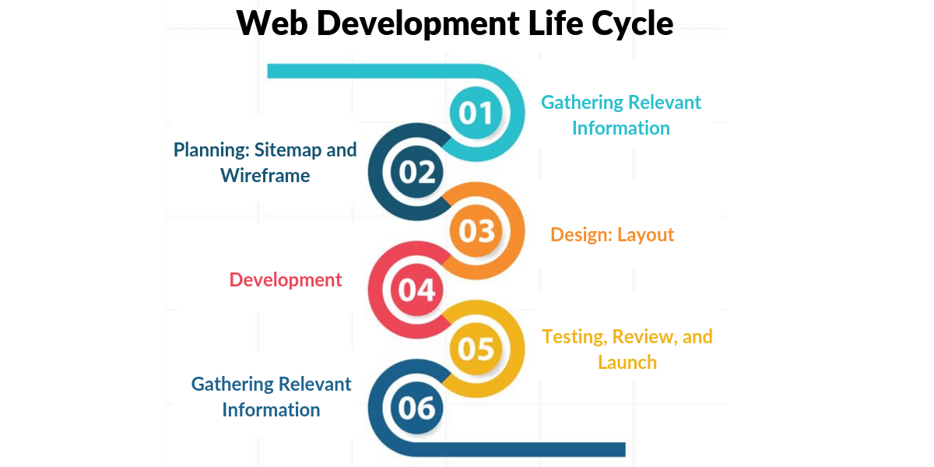

### Development Model

* *The model to be used in the development of the system*
* *Discuss the activities done in each stage.*

### Requirements Analysis

* *Discuss the details of the current system (how the current procedures are performed)*
* *Create a* ***USE case diagram of the current system***

### Requirements Documentation

* *All software features are enumerated in detail by providing storyboard showing how the proposed system will look like.*
* *Requirements documentation is the description of what a particular software does or shall do. It is used throughout development to communicate how the software functions or how it is intended to operate. It is also used as an agreement or as the foundation for agreement on what the software will do. Requirements are produced and consumed by everyone involved in the production of software, including:  end-users, customers, project managers, sales, marketing, software architects, usability engineers, interaction designers, developers, and testers.*
* ***System Use Case diagram***
* ***Activity Diagram***

### System Design

* *Describe how the software or tools are used in the development of the system.*
* ***Entity Relationship diagram,***
* ***Class Diagram,***
* ***Data Dictionaries,***
* ***System Architecture,***
* ***Database Schema of the developed system.***